DB-1 Project Phase-3

**NAME:**

MOHIT SHAILESH KULKARNI - 1002031021

KEDAR KIRAN PENURKAR - 1002033676

***Create a web interface and perform the following operations through the interface and display appropriate   
results.***

**WEBINTERFACE :-**

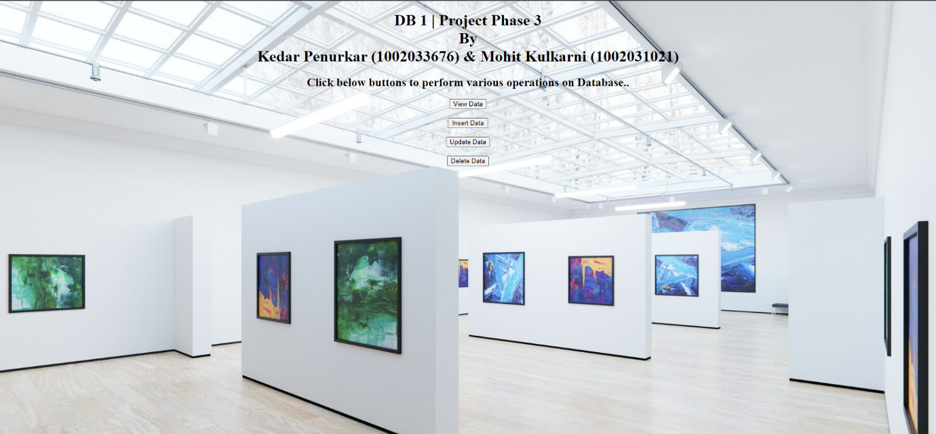

**Q1. Display the customer details based on any one of the following: state name or stateAb (For example Texas or TX)**

**=>**

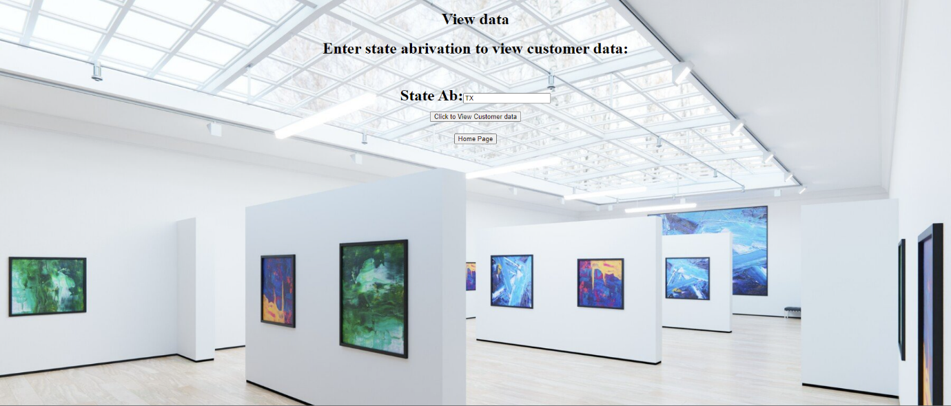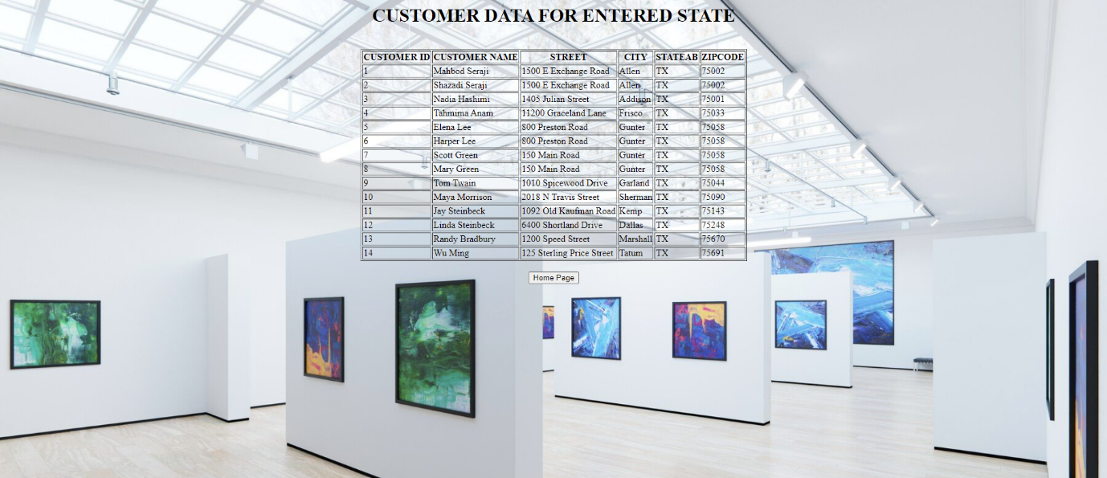

**Q2. Insert a new state ‘Alaska’, ‘AA’ in the art gallery database using the web interface you created.**

**=>**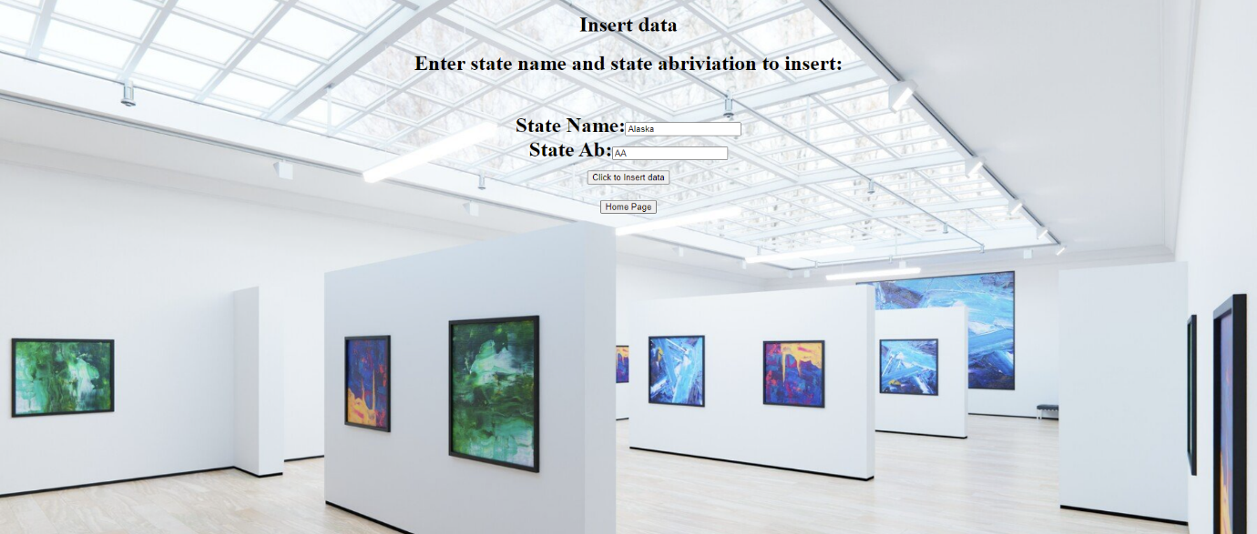

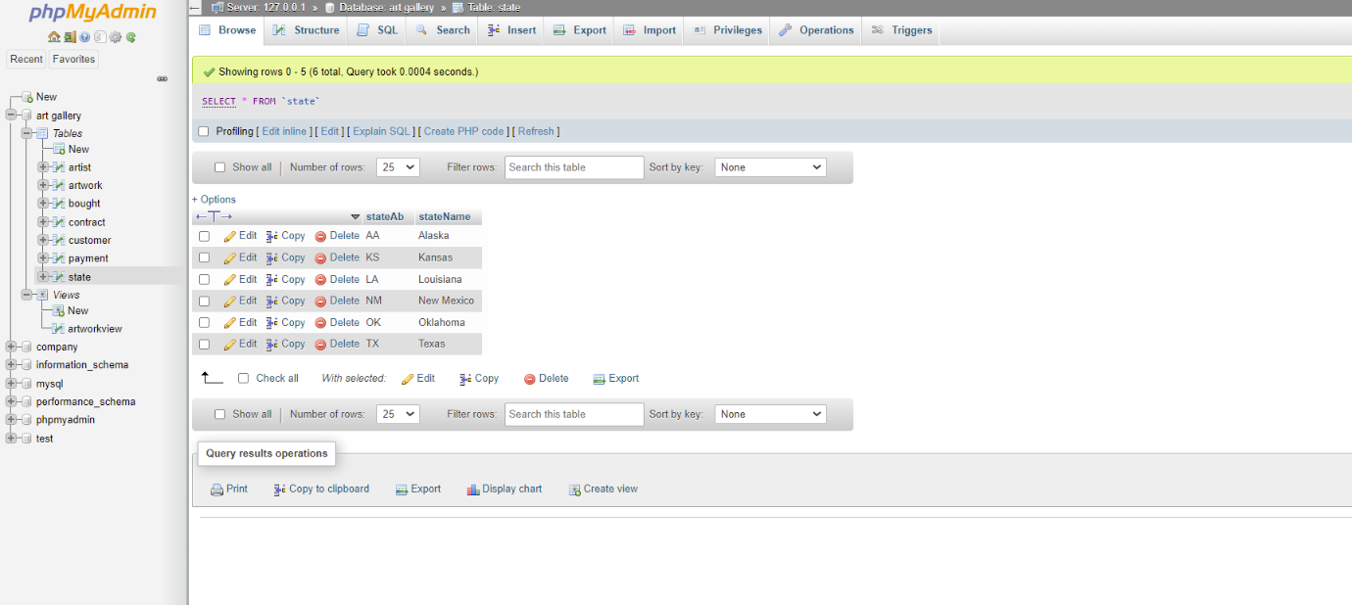

Q3. Update the state record that you just added to ‘Alaska’, ‘AK’ using the web interface you created.

=>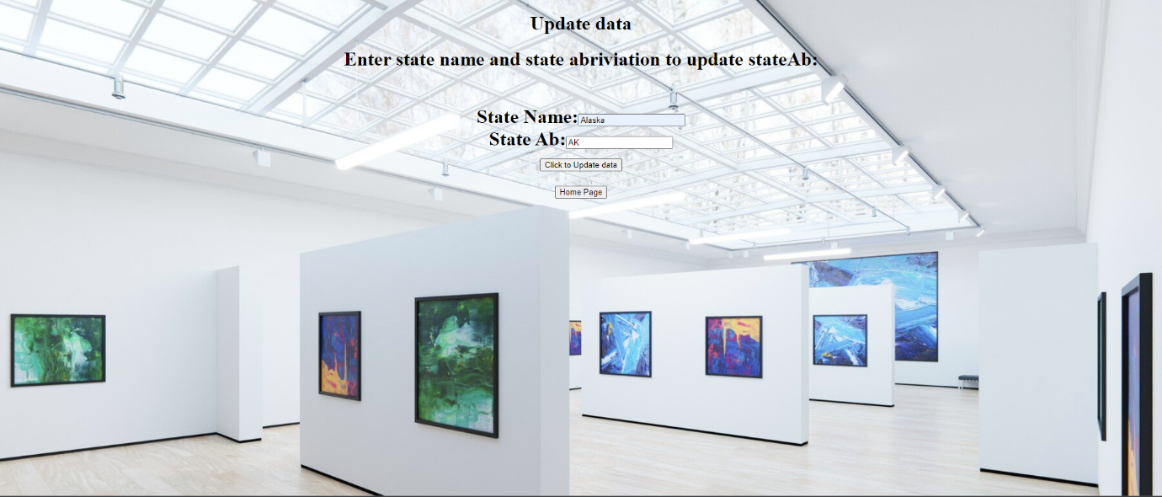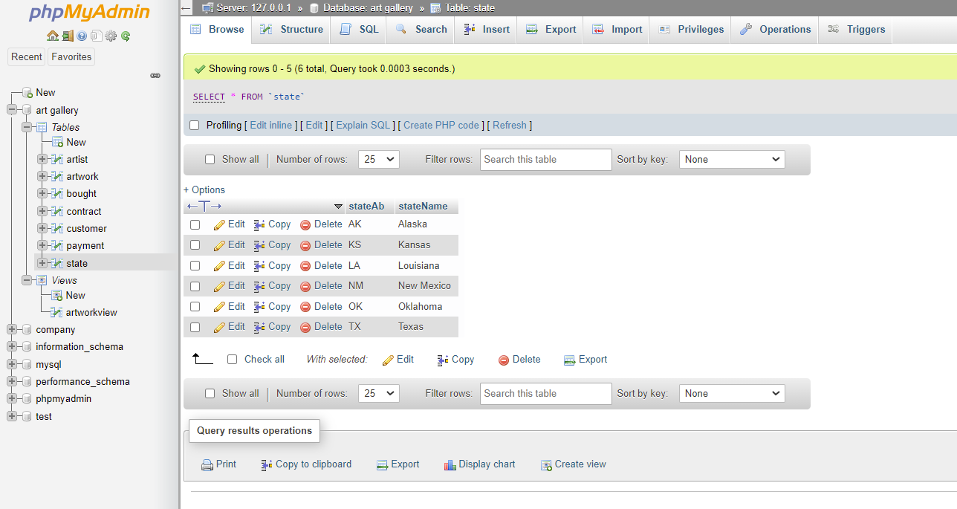

Q4. Delete the state of Alaska record that you just added using the web interface you created.

=>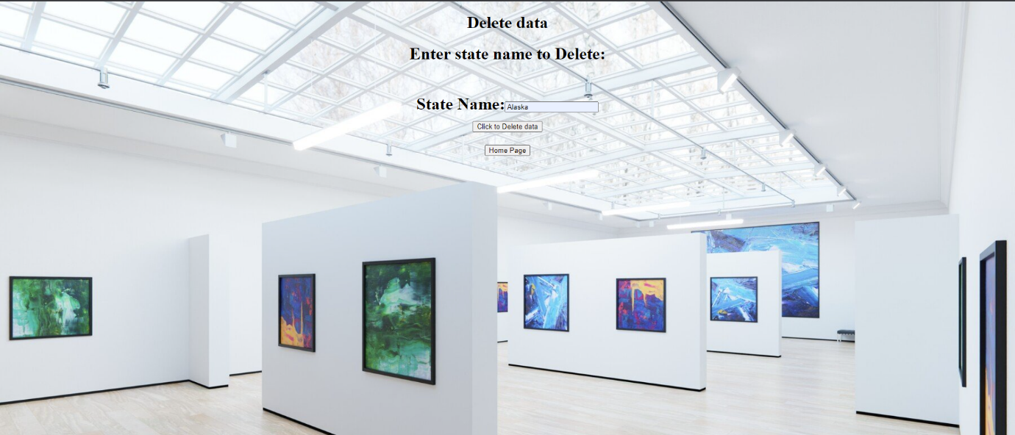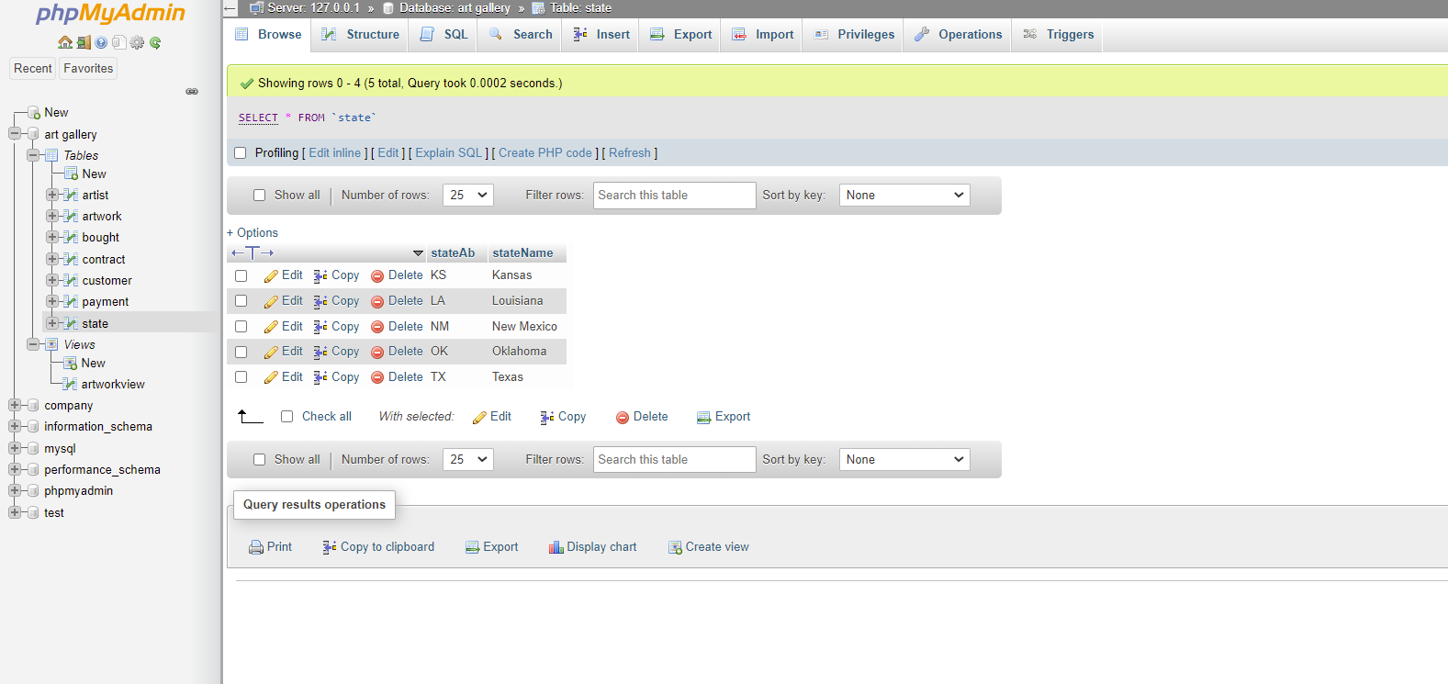

***View-based questions:***

QV1 Create a view ArtworkView that shows name of artist as ArtistName, his date of birth as Bdate, title of the artwork as ArtworkTitle, the form of artwork as Form, the sale date as SaleDate, the price as ArtworkPrice, the customer’s name   
who bought the artwork as CustomerName, final date of the payment as FinalPaymentDate, and the acquisition date of that artwork as AcquisitionDate. Records should be sorted by the name of the artist.

**=>**

CREATE VIEW ArtworkView(ArtistName,Bdate,ArtworkTitle,Form,SaleDate,ArtworkPrice,CustomerName,FinalPaymentDate,AcquisitionDate)

AS SELECT A.name, A.birthDate, AW.title, AW.form, B.saleDate, AW.price, C.name, PY.finalDate, AW.acquisitionDate

FROM ARTIST A, ARTWORK AW, BOUGHT B, CUSTOMER C, PAYMENT PY

WHERE A.aID= AW.aID AND AW.artID=B.artID AND B.cID=C.cID AND AW.artID=PY.artID

ORDER BY A.name;

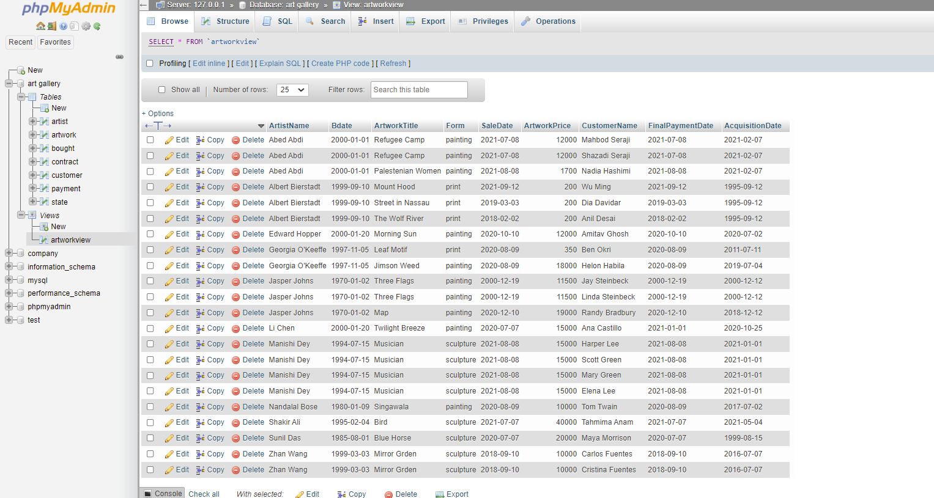

QV2 Use the view ArtworkView to retrieve a list of unique names of the artists and their customers when both the names   
start with vowels.

=>

SELECT DISTINCT ArtistName,CustomerName

FROM ArtworkView

WHERE (ArtistName LIKE 'A%'

OR ArtistName LIKE 'E%'

OR ArtistName LIKE 'I%'

OR ArtistName LIKE 'O%'

OR ArtistName LIKE 'U%')

AND (CustomerName LIKE 'A%'

OR CustomerName LIKE 'E%'

OR CustomerName LIKE 'I%'

OR CustomerName LIKE 'O%'

OR CustomerName LIKE 'U%');

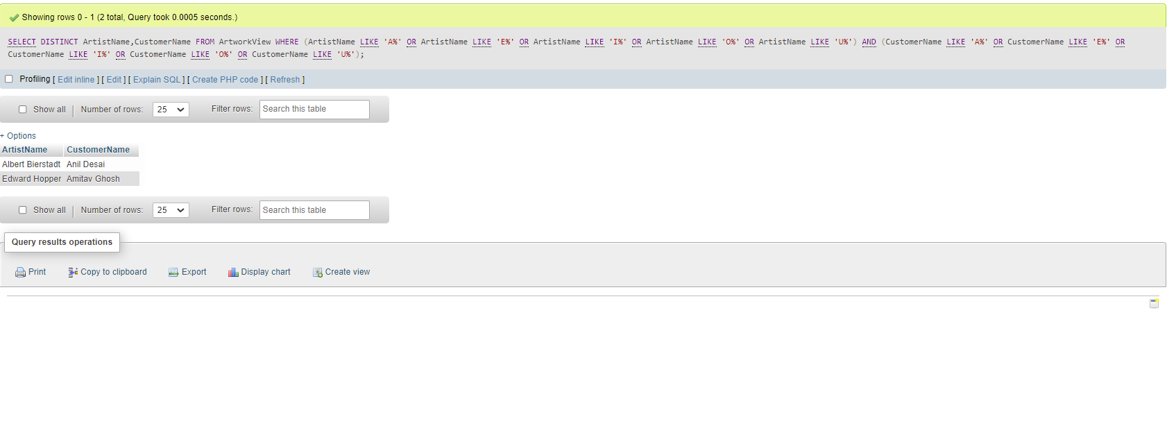

**QV3 Use the view ArtworkView to retrieve a list of unique names of the artists whose artwork form is painting.**

**=>**

**SELECT DISTINCT ArtistName**

**FROM ArtworkView**

**WHERE Form='painting';**

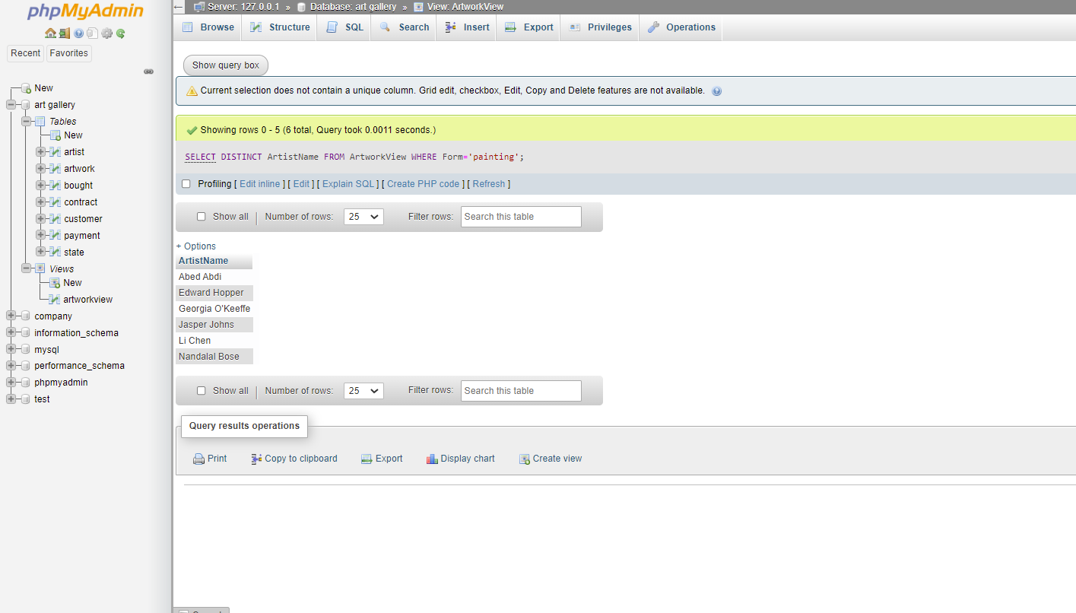

**QV4 Use the view ArtworkView to retrieve a list of unique names of the artists, artwork title, and the price when the price is greater than $250.00 and less than $15,000.00**

**=>**

**SELECT DISTINCT ArtistName,ArtworkTitle,concat('$' , format((ArtworkView.ArtworkPrice),2)) as ArtworkPrice**

**FROM ArtworkView**

**WHERE ArtworkPrice > 250 AND ArtworkPrice < 15000;**

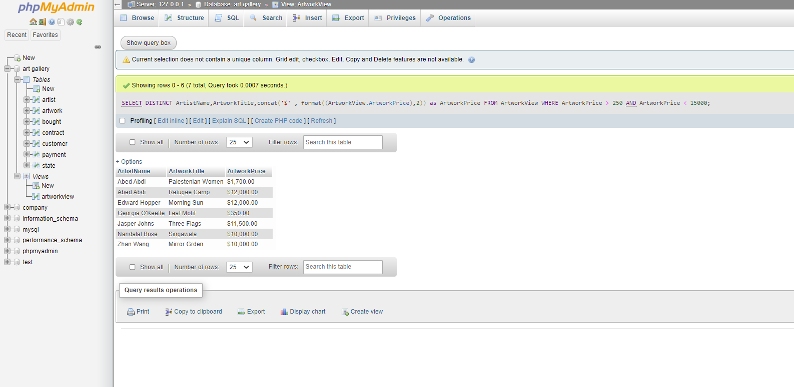

**QV5 Use the view ArtworkView to list the names of the artists and the total number of their art pieces sold so far at the   
gallery.**

**=>**

**SELECT ArtistName, COUNT(SaleDate) AS NO_OF_PICES_SOLD**

**FROM ArtworkView**

**GROUP BY ArtistName;**

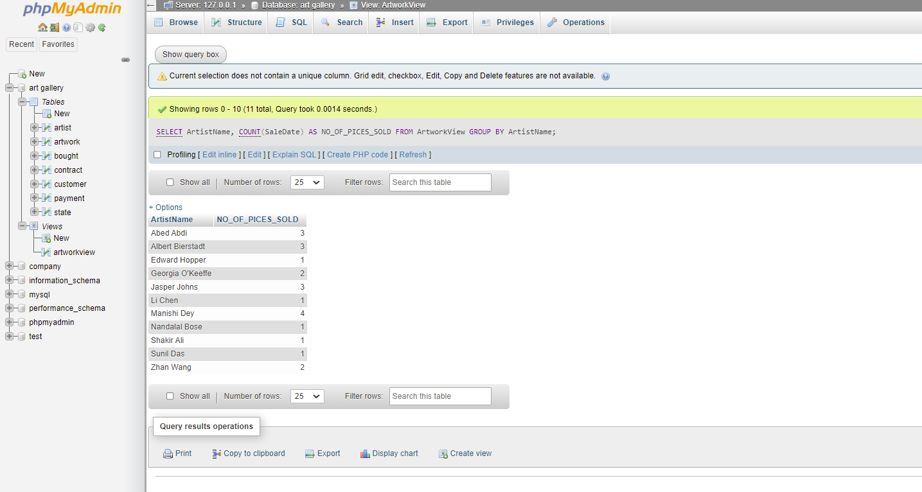

**QV6 For all the artwork that were acquired on 9th September 1995 (1995-09-12), retrieve the name of the artist, his/her   
date of birth, the title of their artwork, sale date, customer name, and final payment date.**

**=>**

**SELECT A.name AS ArtistName, A.birthdate AS Bdate, AW.title AS ArtworkTitle, AW.acquisitionDate AS acquisitionDate, B.saleDate, CUST.name AS CustomerName, PY.finalDate AS FinalPaymentDate**

**FROM artist A**

**LEFT JOIN artwork AW**

**ON A.aID = AW.aID**

**LEFT JOIN bought B**

**ON AW.artID = B.artID**

**LEFT JOIN payment PY**

**ON AW.artID = PY.artID**

**LEFT OUTER JOIN customer CUST**

**ON CUST.cID = B.cID**

**WHERE AW.acquisitionDate = '1995-09-12';**

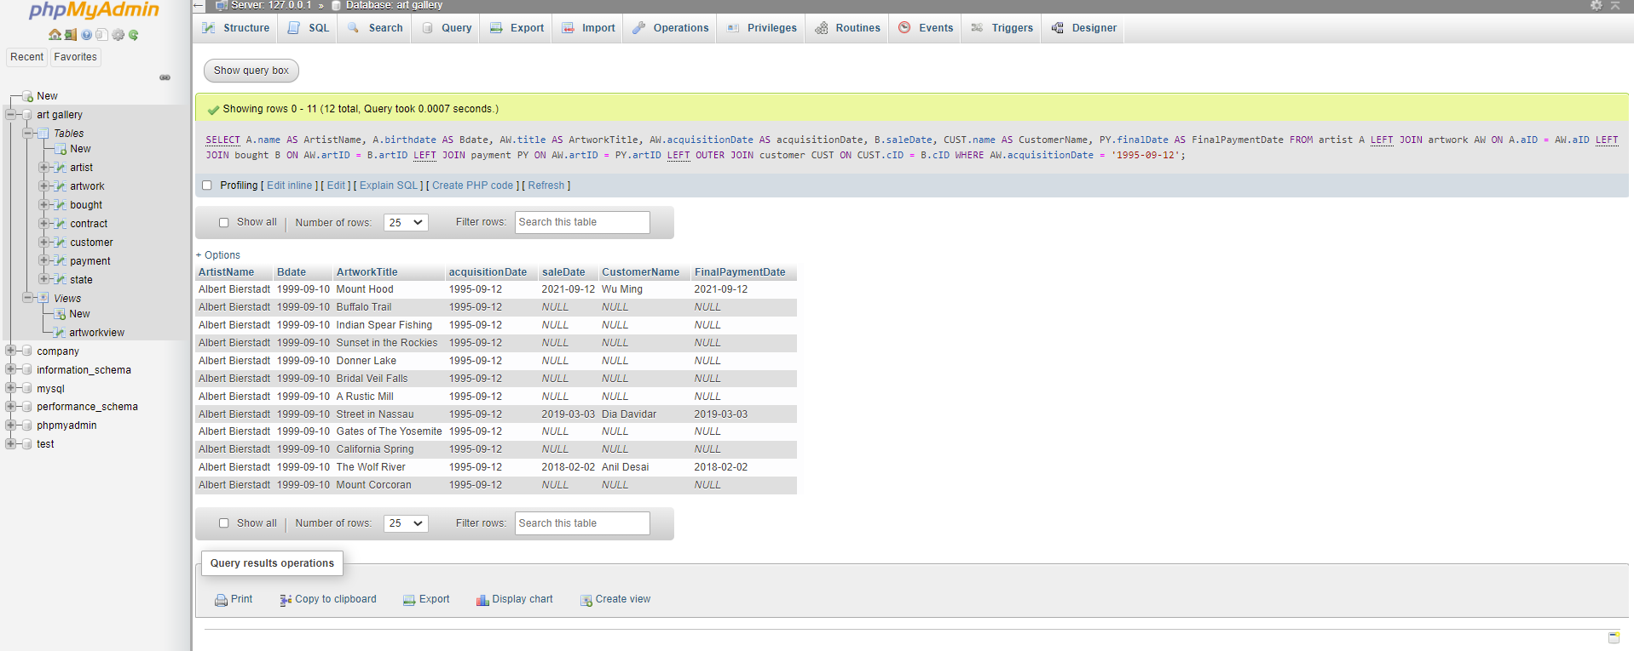

**HONOR CODE**

